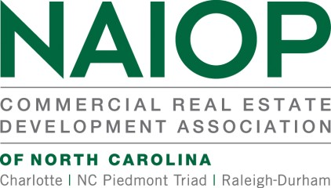
NAIOP represents the interests of 19,000+ commercial real estate professionals throughout North America. NAIOP is the leading organization for developers, owners and related professionals in office, industrial and mixed-use real estate with three (3) North Carolina chapters with over 500 members. NAIOP advances responsible commercial real estate development and advocates for effective public policy.

2023 Legislative Priorities

ECONOMIC DEVELOPMENT

- We support legislative initiatives to ensure the state has the necessary tools to attract and retain economic development and investment in order to remain competitive with neighboring states.
- We support a comprehensive economic development strategy that provides the state with the necessary tools to spur economic opportunity and job creation and to adapt to industry trends that benefits all business, both small and large.
- We support legislative efforts to advance a tax structure that drives a strong and healthy state economy.
- We support legislative efforts to fund critical transportation and infrastructure projects that are needed to drive
economic development and the state’s competitiveness in the region.
- We support legislative efforts to strengthen workforce development programs in order to provide individuals with the training and skills for a future in commercial real estate development.

TAX REFORM

- We support legislation that incentivizes the adaptive reuse of vacant and underutilized commercial buildings for residential usage.
- We support legislation that exempts property management fees from sales and use tax on service contracts.
- We oppose legislation to restructure the distribution of local sales tax revenue statewide on per-capita basis.
- We support Historic Preservation Tax Credits and the elimination of its statutory sunset provision.
- We oppose the expansion of government services and programs that may lead to tax increases when the one-time infusion of federal funds provided to the state under the American Rescue Act expires.

REGULATORY REFORM

- We support legislation that streamlines the local development permitting process, reduces review time, and provides greater transparency and certainty for property owners and investors.
- We support legislation to clearly prohibit local governments from adopting mandatory inclusionary zoning ordinances for new multifamily and mixed-use developments.
- We support legislation to ensure the fair and orderly application of new interpretations of the state building code by local governments, which would reduce the cost of new construction by providing regulatory consistency in the building inspection process.
- We support zoning regulation reforms that would encourage growth in commercial development.
- We support voluntary incentive-based and market-oriented regulations to improve energy efficiency in commercial buildings. Updated state codes must include considerations for technological and economic feasibility.
- We support additional staff funding for the North Carolina Brownfields Program to facilitate the efficient redevelopment of underused contaminated properties.

Charlotte 704.940.7383 | Piedmont Triad 336.379.0603 | Raleigh Durham 919.256.2522 | Corporate 703.904.7100

